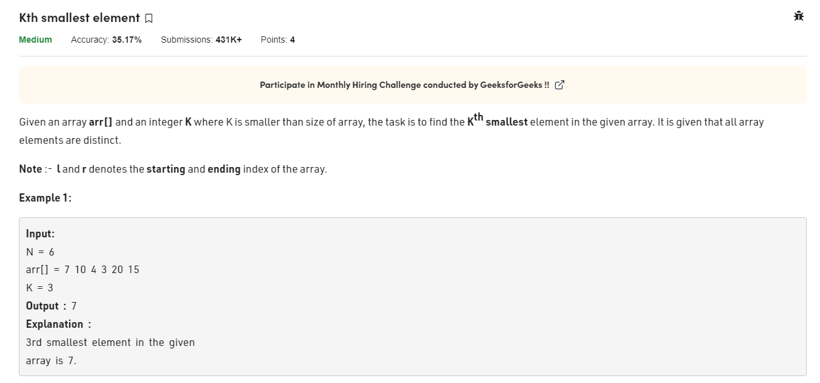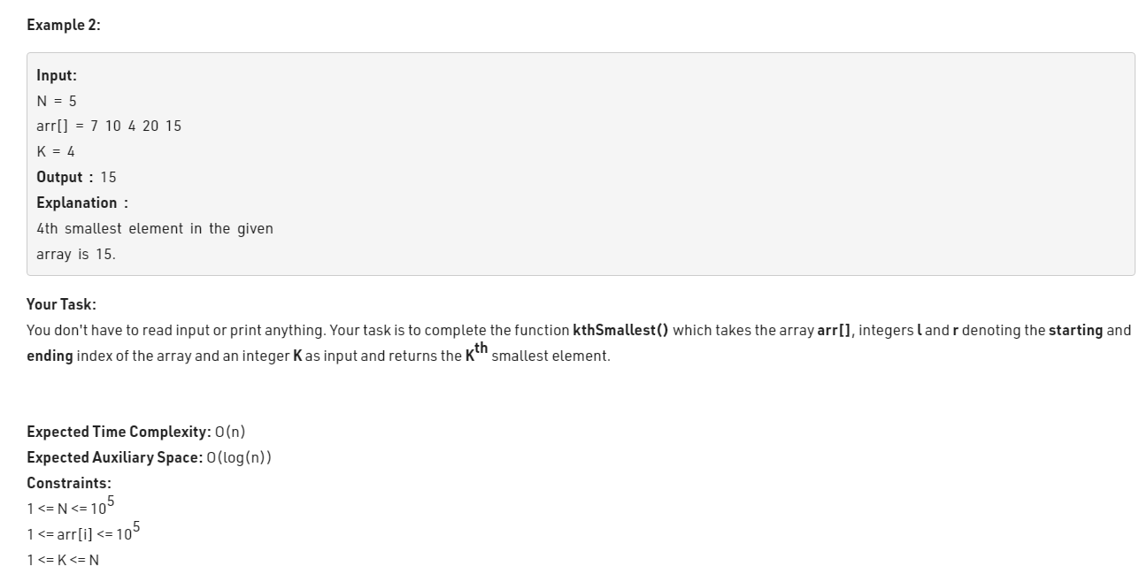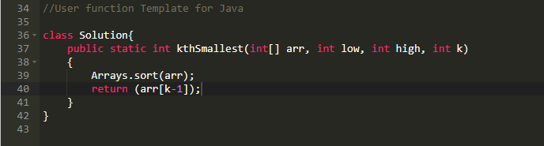class Solution{

public static int kthSmallest(int[] arr, int low, int high, int k)

{

Arrays.sort(arr);

return (arr[k-1]);

}

}